**Image Analysis**

**Critical Analysis – Denoising of PET Images by Context Modelling Using Local Neighbourhood Correlation**

Submitted for the MSc in

Advanced Computer Science

April 18

By

**Alexander C Whitehead**

Word Count: 0

Table of Contents

1 Introduction 4

2 Criticism 5

2.1 Title 5

2.2 Authors 5

2.3 Acknowledgements 5

2.4 Abstract 5

2.5 Introduction 5

2.6 Materials and Methods 5

2.6.1 Table 1 5

2.7 Results 6

2.7.1 Figure 1 6

2.7.2 Table 2 7

2.7.3 Figure 2 7

2.7.4 Table 3 8

2.7.5 Table 4 9

2.7.6 Figure 3 10

2.7.7 Table 5 11

2.7.8 Table 6 12

2.7.9 Figure 4 12

2.7.10 Figure 5 13

2.7.11 Figure 6 14

2.7.12 Figure 7 15

2.8 Discussion 16

2.9 References 16

3 Conclusion 17

References 18

Table of Figures

Figure 1: This image shows the first table used in the paper Denoising of PET Images by Context Modelling Using Local Neighbourhood Correlation (Huerga, et al., 2017). 6

Figure 2: This image shows the first figure used in the paper Denoising of PET Images by Context Modelling Using Local Neighbourhood Correlation with the caption of “The autocorrelation function normalised to the maximum pixel value: (a) 2D image, (b) display of matrices of weight for the first level. Diagonal orientation (top) and horizontal (bottom).” (Huerga, et al., 2017). 6

Figure 3: This image shows the second table used in the paper Denoising of PET Images by Context Modelling Using Local Neighbourhood Correlation (Huerga, et al., 2017). 7

Figure 4: This image shows the second figure used in the paper Denoising of PET Images by Context Modelling Using Local Neighbourhood Correlation with the caption of “A profile plot for the cylindrical phantom with nominal (injected) activity of 39.0 kBq ml−1. The profile was taken horizontally, from the middle of the phantom.” (Huerga, et al., 2017). 8

Figure 5: This image shows the third table used in the paper Denoising of PET Images by Context Modelling Using Local Neighbourhood Correlation (Huerga, et al., 2017). 9

Figure 6: This image shows the fourth table used in the paper Denoising of PET Images by Context Modelling Using Local Neighbourhood Correlation (Huerga, et al., 2017). 10

Figure 7: This image shows the third figure used in the paper Denoising of PET Images by Context Modelling Using Local Neighbourhood Correlation with the caption of “A visual evaluation in the LOW-CONTRAST case. Top: image without post reconstruction filter (left), standard Gaussian filter processing (middle), wavelet filter processing described (right). Bottom: profiles through smaller spheres (peaks corresponding to the spheres of diameters 13 mm, 17 mm, 10 mm and 22 mm, left to right).” (Huerga, et al., 2017). 11

Figure 8: This image shows the fifth table used in the paper Denoising of PET Images by Context Modelling Using Local Neighbourhood Correlation (Huerga, et al., 2017). 12

Figure 9: This image shows the sixth table used in the paper Denoising of PET Images by Context Modelling Using Local Neighbourhood Correlation (Huerga, et al., 2017). 12

Figure 10: This image shows the fourth figure used in the paper Denoising of PET Images by Context Modelling Using Local Neighbourhood Correlation with the caption of “A comparison of the SUVmean (top) and SUVmax (bottom) reduction rates (%) in more than 40 lesions from different patients.” (Huerga, et al., 2017). 13

Figure 11: This image shows the fifth figure used in the paper Denoising of PET Images by Context Modelling Using Local Neighbourhood Correlation with the caption of “Example patient 1; coronal slice with liver lesions. Top: image without post- reconstruction filter (left), standard Gaussian filter processing (middle), wavelet filter processing described (right). Bottom: the profiles for each image through the lesion are shown.” (Huerga, et al., 2017). 14

Figure 12: This image shows the sixth figure used in the paper Denoising of PET Images by Context Modelling Using Local Neighbourhood Correlation with the caption of “Example patient 2; coronal slice with mediastinum lesion. Top: image without post-reconstruction filter (left), standard Gaussian filter processing (middle), wavelet filter processing described (right). Bottom: profiles are shown for each image throughout the lesion.” (Huerga, et al., 2017). 15

Figure 13: This image shows the seventh figure used in the paper Denoising of PET Images by Context Modelling Using Local Neighbourhood Correlation with the caption of “Example patient 3; head and neck segmentation (top). Example patient 4; liver segmentation. The images on the left were processed with a 3D extension, the ones on the right were processed without.” (Huerga, et al., 2017). 16

# Introduction

This is a report critically analysing the paper; Denoising of PET Images by Context Modelling Using Local Neighbourhood Correlation.

This report will first critically analyse the title and authors of the paper before moving on to analyse each section of the paper in the order that they would be expected to be appear if the paper was written in a conventional fashion.

This order is:

1. Acknowledgements
2. Abstract
3. Introduction
4. Materials and Methods (containing analysis of select tables and figures)
5. Results (containing analysis of select tables and figures)
6. Discussion
7. References

# Critical Analysis

## Title

## Authors

## Acknowledgements

## Abstract

## Introduction

## Materials and Methods

## Table 1

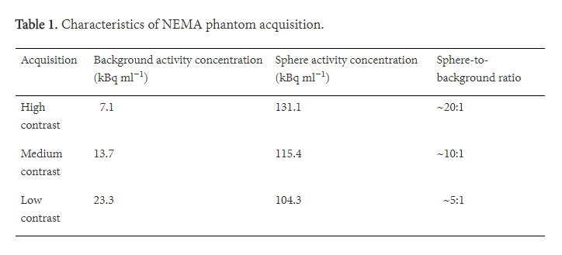

Figure 1: This image shows the first table used in the paper Denoising of PET Images by Context Modelling Using Local Neighbourhood Correlation (Huerga, et al., 2017).

## Results

## Figure 1

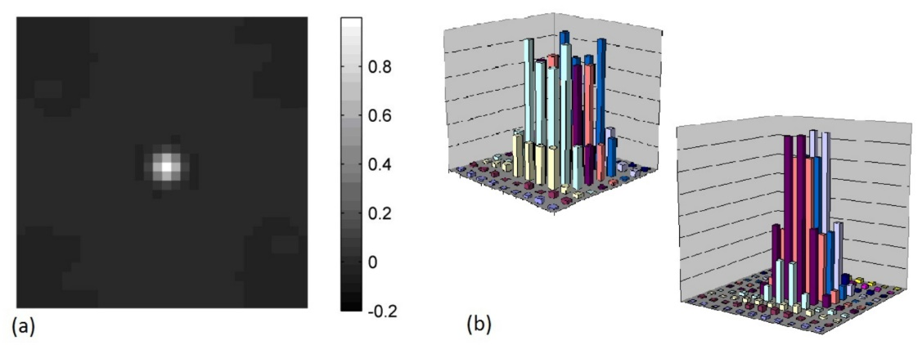

Figure 2: This image shows the first figure used in the paper Denoising of PET Images by Context Modelling Using Local Neighbourhood Correlation with the caption of “The autocorrelation function normalised to the maximum pixel value: (a) 2D image, (b) display of matrices of weight for the first level. Diagonal orientation (top) and horizontal (bottom).” (Huerga, et al., 2017).

## Table 2

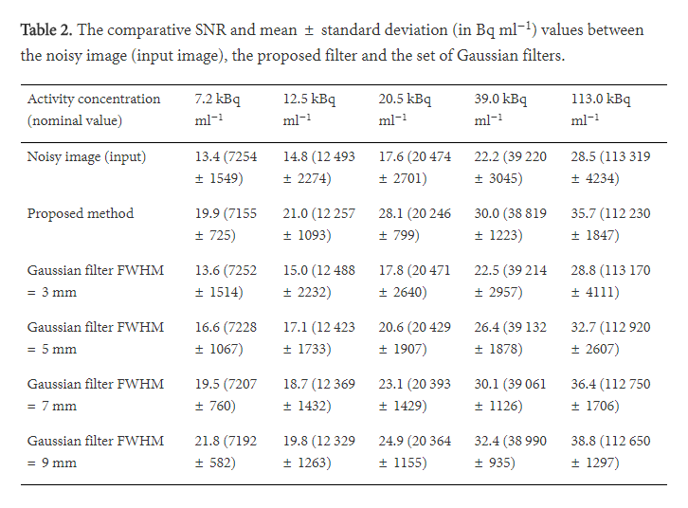

Figure 3: This image shows the second table used in the paper Denoising of PET Images by Context Modelling Using Local Neighbourhood Correlation (Huerga, et al., 2017).

## Figure 2

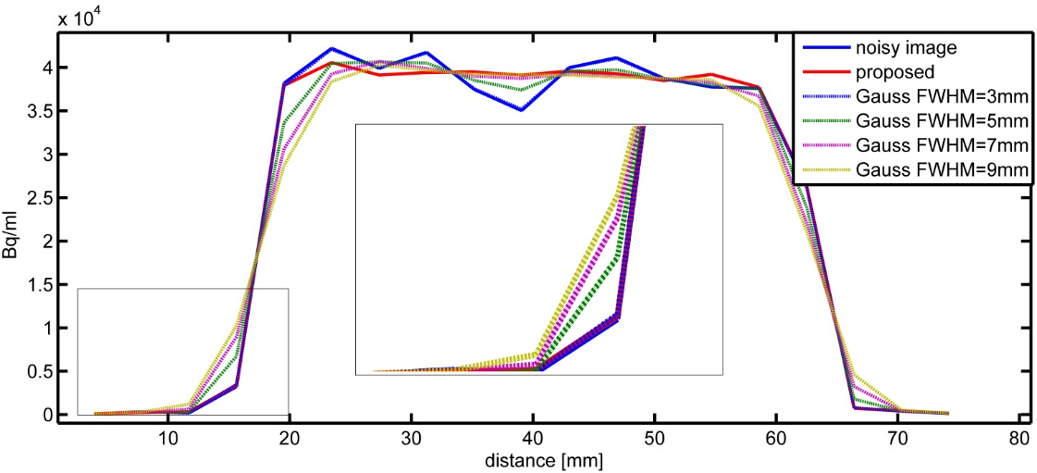

Figure 4: This image shows the second figure used in the paper Denoising of PET Images by Context Modelling Using Local Neighbourhood Correlation with the caption of “A profile plot for the cylindrical phantom with nominal (injected) activity of 39.0 kBq ml−1. The profile was taken horizontally, from the middle of the phantom.” (Huerga, et al., 2017).

## Table 3

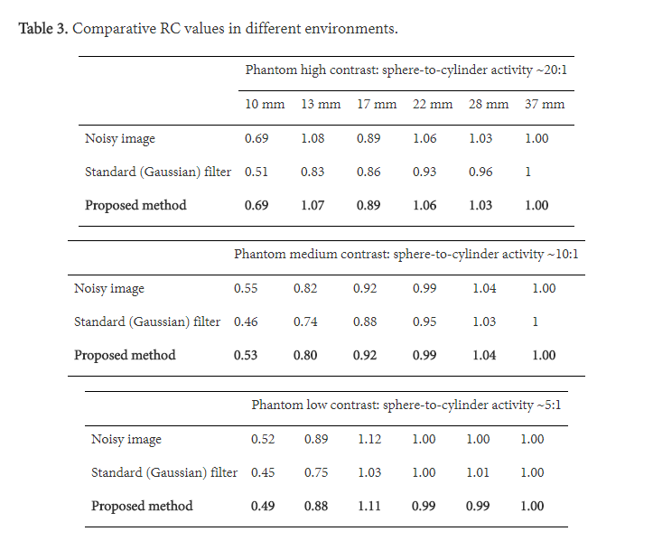

Figure 5: This image shows the third table used in the paper Denoising of PET Images by Context Modelling Using Local Neighbourhood Correlation (Huerga, et al., 2017).

## Table 4

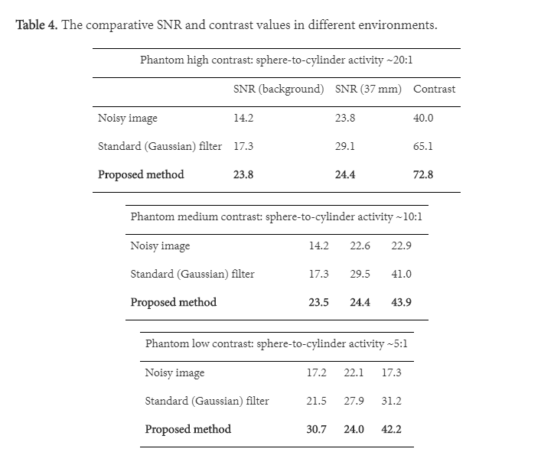

Figure 6: This image shows the fourth table used in the paper Denoising of PET Images by Context Modelling Using Local Neighbourhood Correlation (Huerga, et al., 2017).

## Figure 3

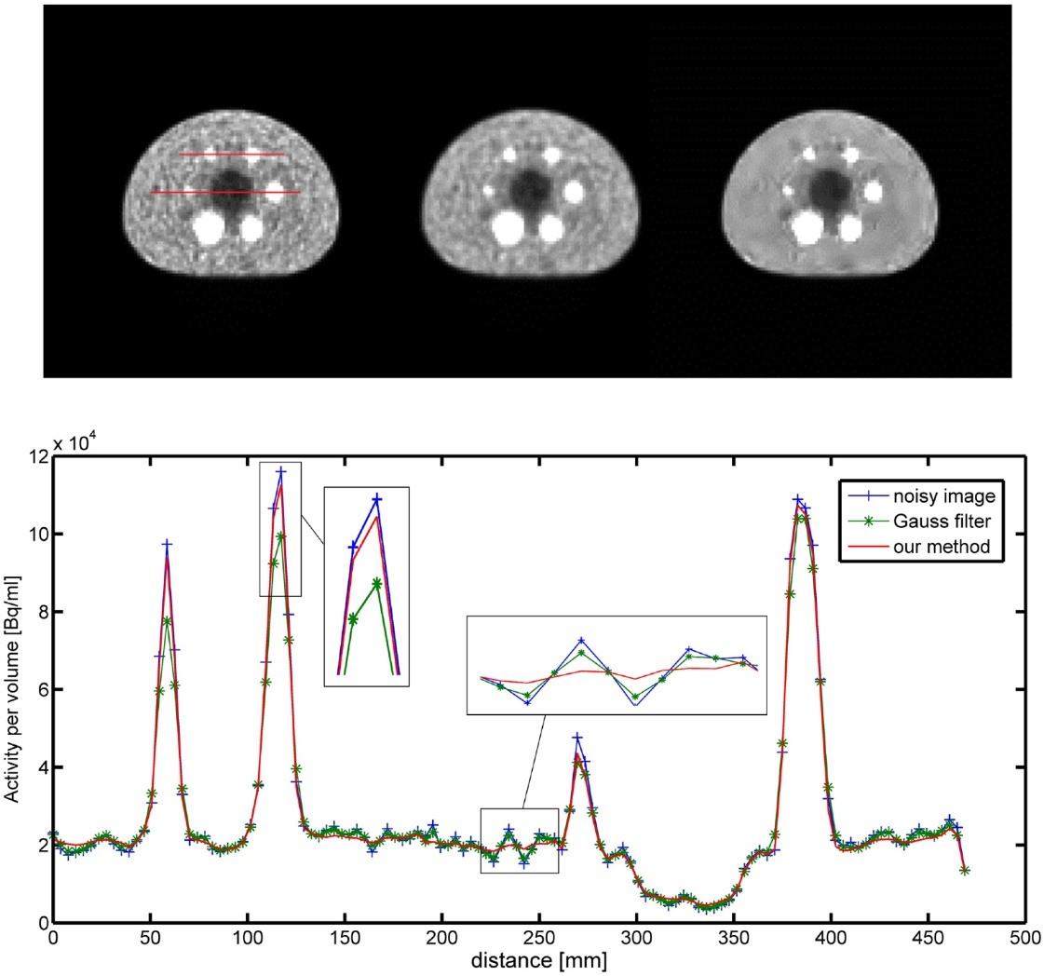

Figure 7: This image shows the third figure used in the paper Denoising of PET Images by Context Modelling Using Local Neighbourhood Correlation with the caption of “A visual evaluation in the LOW-CONTRAST case. Top: image without post reconstruction filter (left), standard Gaussian filter processing (middle), wavelet filter processing described (right). Bottom: profiles through smaller spheres (peaks corresponding to the spheres of diameters 13 mm, 17 mm, 10 mm and 22 mm, left to right).” (Huerga, et al., 2017).

## Table 5

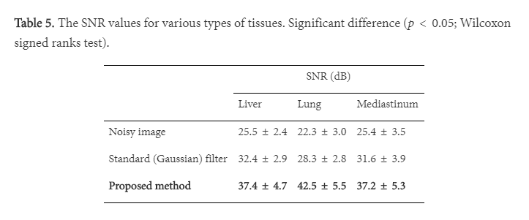

Figure 8: This image shows the fifth table used in the paper Denoising of PET Images by Context Modelling Using Local Neighbourhood Correlation (Huerga, et al., 2017).

## Table 6

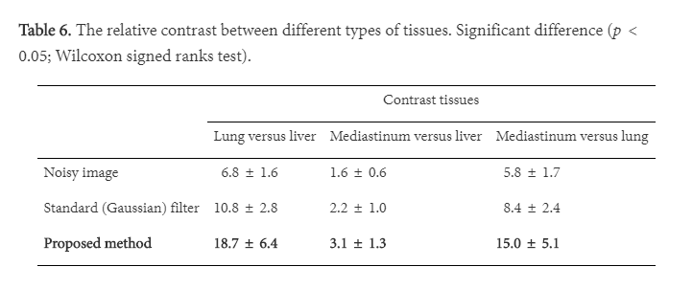

Figure 9: This image shows the sixth table used in the paper Denoising of PET Images by Context Modelling Using Local Neighbourhood Correlation (Huerga, et al., 2017).

## Figure 4

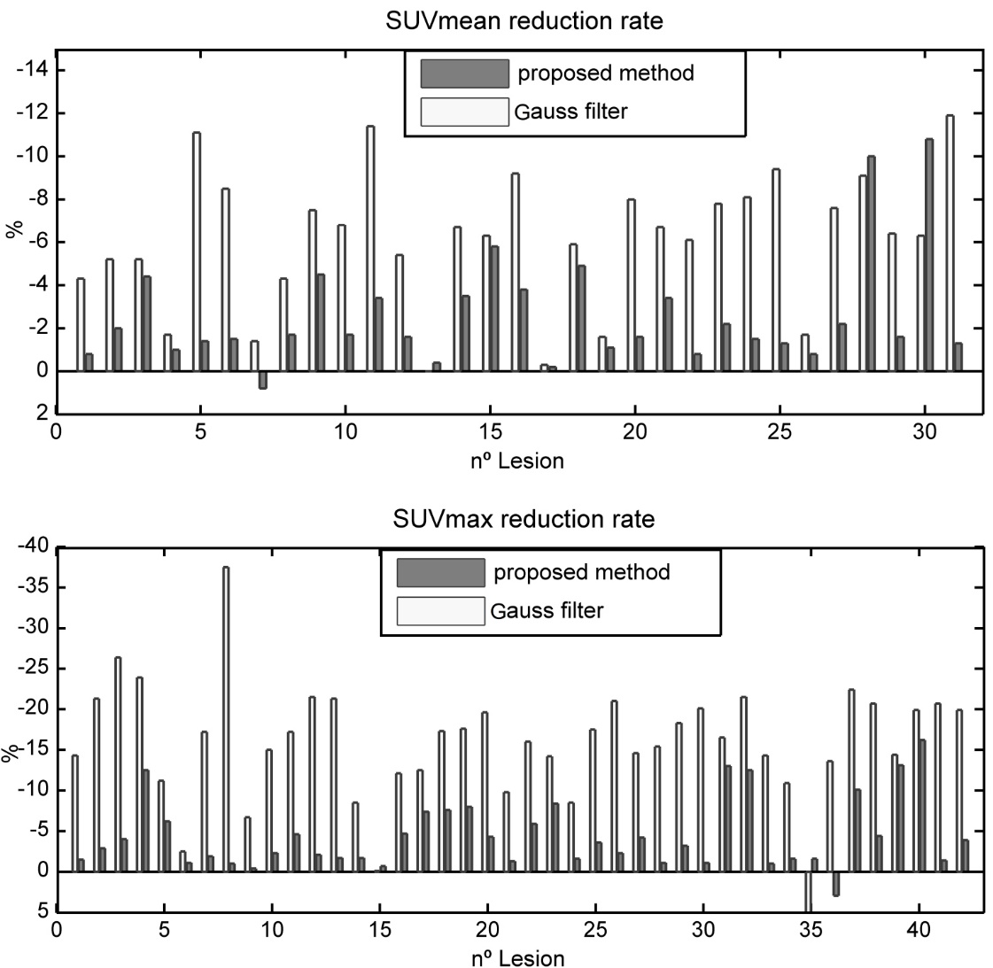

Figure 10: This image shows the fourth figure used in the paper Denoising of PET Images by Context Modelling Using Local Neighbourhood Correlation with the caption of “A comparison of the SUVmean (top) and SUVmax (bottom) reduction rates (%) in more than 40 lesions from different patients.” (Huerga, et al., 2017).

## Figure 5

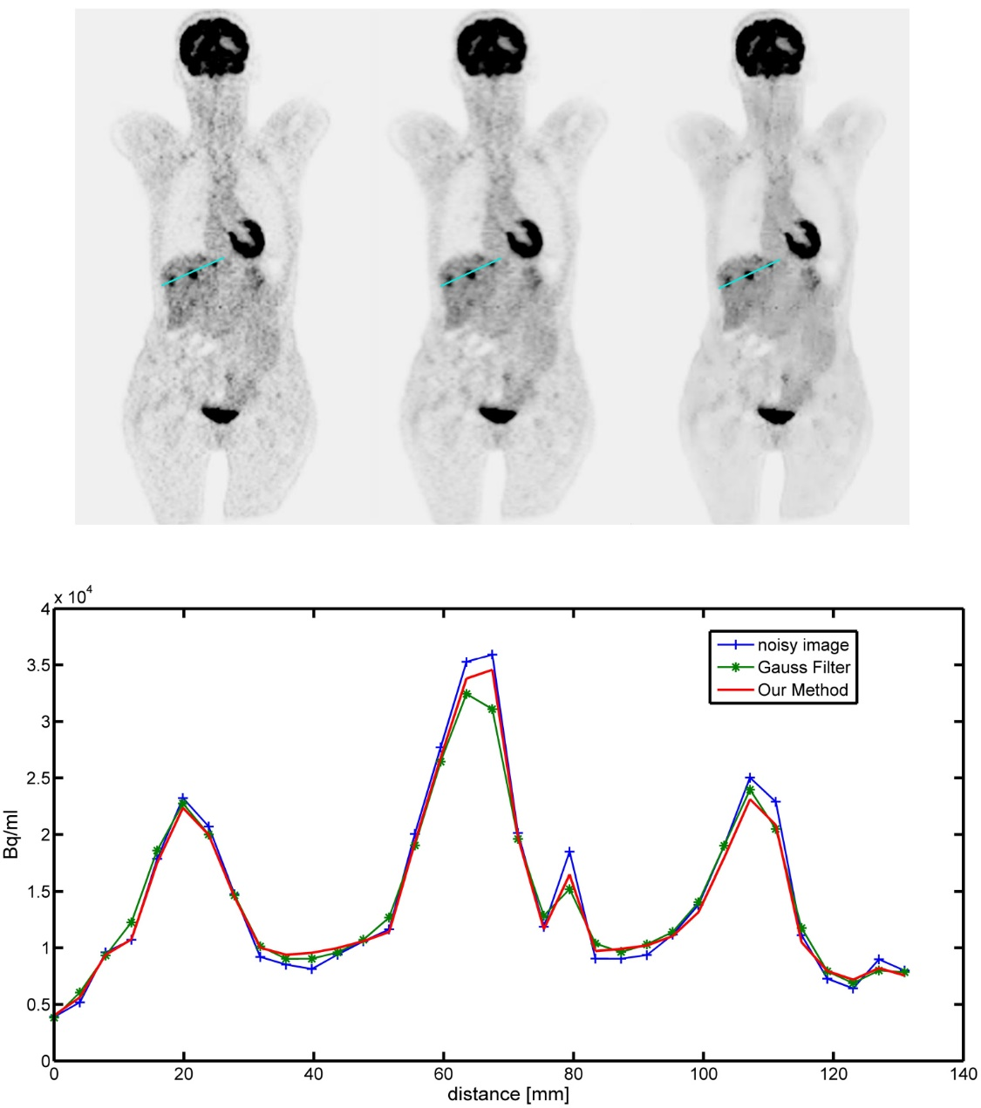

Figure 11: This image shows the fifth figure used in the paper Denoising of PET Images by Context Modelling Using Local Neighbourhood Correlation with the caption of “Example patient 1; coronal slice with liver lesions. Top: image without post- reconstruction filter (left), standard Gaussian filter processing (middle), wavelet filter processing described (right). Bottom: the profiles for each image through the lesion are shown.” (Huerga, et al., 2017).

## Figure 6

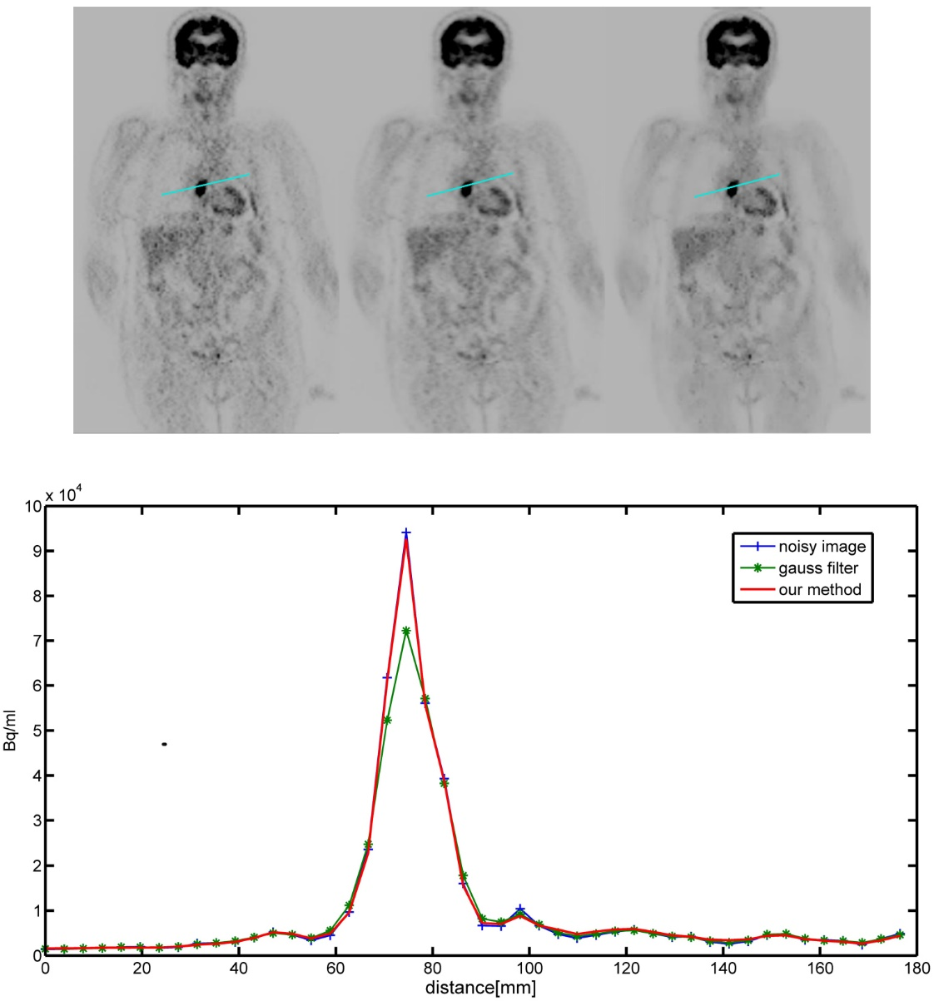

Figure 12: This image shows the sixth figure used in the paper Denoising of PET Images by Context Modelling Using Local Neighbourhood Correlation with the caption of “Example patient 2; coronal slice with mediastinum lesion. Top: image without post-reconstruction filter (left), standard Gaussian filter processing (middle), wavelet filter processing described (right). Bottom: profiles are shown for each image throughout the lesion.” (Huerga, et al., 2017).

## Figure 7

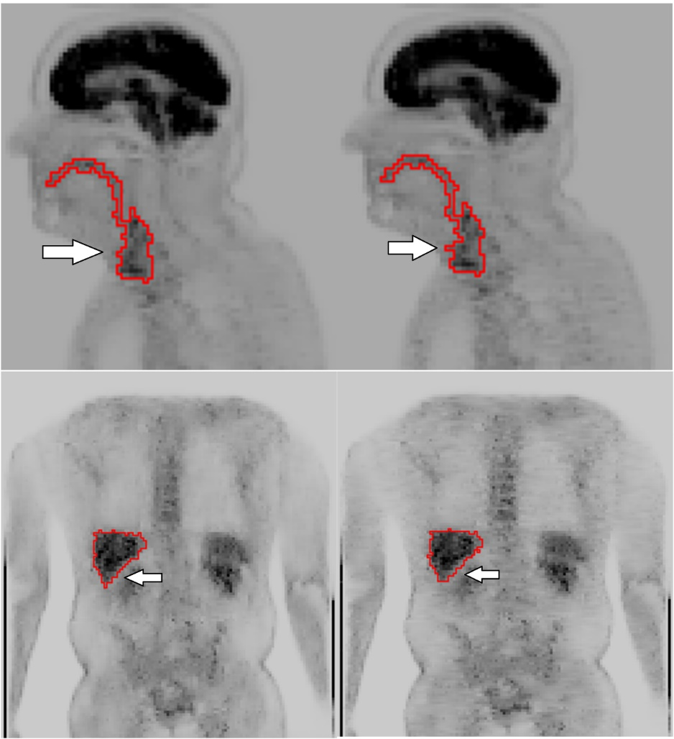

Figure 13: This image shows the seventh figure used in the paper Denoising of PET Images by Context Modelling Using Local Neighbourhood Correlation with the caption of “Example patient 3; head and neck segmentation (top). Example patient 4; liver segmentation. The images on the left were processed with a 3D extension, the ones on the right were processed without.” (Huerga, et al., 2017).

## Discussion

## References

# Conclusion

References

Huerga, C. et al., 2017. Denoising of PET images by context modelling using local neighbourhood correlation. *Physics in Medicine & Biology,* 62(2), pp. 633-651.